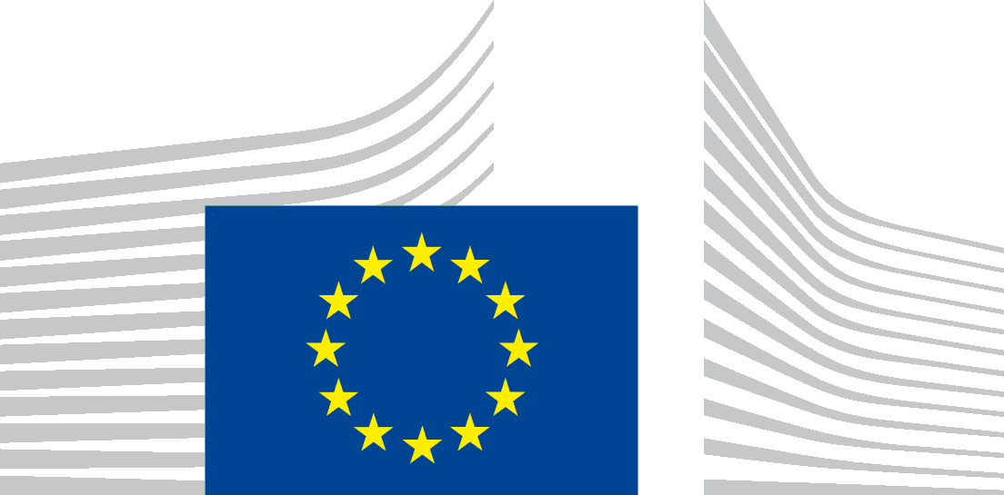 | EUROPEAN COMMISSION
PROTECTION OF YOUR PERSONAL DATA
Processing operation: Management of subscriptions to receive information via Newsroom
Data Controller: European Commission, Directorate-General for Communication, COMM.C.3 Citizens’ Dialogues
Data Processor: European Commission, DG Connect, Unit R.3
Record reference: DPR-EC-03928

Table of Contents
- Introduction
- Why and how do we process your personal data?
- On what legal ground(s) do we process your personal data?
- Which personal data do we collect and further process?
- How long do we keep your personal data?
- How do we protect and safeguard your personal data?
- Who has access to your personal data and to whom is it disclosed?
- What are your rights and how can you exercise them?
- Contact information
- Where to find more detailed information?

1. Introduction
The European Commission is committed to protecting your personal data and to respecting your privacy. The Commission collects and further processes personal data pursuant to Regulation (EU) 2018/1725 of the European Parliament and of the Council of 23 October 2018 on the protection of natural persons with regard to the processing of personal data by the Union institutions, bodies, offices and agencies and on the free movement of such data.
This privacy statement explains the reason for the processing of your personal data, the way we collect, handle and ensure protection of all personal data provided, how that information is used and what rights you have in relation to your personal data. It also specifies the contact details of the responsible Data Controller with whom you may exercise your rights, the Data Protection Officer and the European Data Protection Supervisor.
The information in relation to the processing operation “Management of subscriptions to receive information via Newsroom”, undertaken by the services of the European Commission, is presented below.
2. Why and how do we process your personal data?
Purpose of the processing operation: the Data Controller collects and further processes your personal data so that you can receive information that you have requested on different topics in the area of (a) service(s) of the European Commission through our newsletter or notifications.
Your personal data will not be used for an automated decision-making including profiling.

3. On what legal ground(s) do we process your personal data?
You have subscribed to receive the information on different topics in the area of (a) service(s) of the European Commission.
We process your personal data, because you have given your consent to the processing of your personal data for the purpose of receiving the requested information through our newsletter or notifications.
4. Which personal data do we collect and further process?
In order to carry out this processing operation, the Data Controller collects the following categories of personal data:

- your e-mail address;
- frequency of notifications, and
- topics of interest.

These personal data are needed to ensure the delivery of the service to you as a subscriber.
5. How long do we keep your personal data?
The Data Controller only keeps your personal data for a period of five years after your last interaction with the Commission Services or until you request the deletion of your personal data.
If you have created a profile to benefit from the services of the Connect Newsroom, you may edit the personal data associated at any time. You can also delete your profile and the personal data associated to your profile.
You can also write to the dedicated mailbox COMM-CITIZENS-PANELS@ec.europa.eu and ask to be unsubscribed from the mailing list or follow the unsubscribe link in the information email you have received.
6. How do we protect and safeguard your personal data?
All personal data in electronic format (e-mails, documents, databases, uploaded batches of data, etc.) are stored on the servers of the European Commission. All processing operations are carried out pursuant to the Commission Decision (EU, Euratom) 2017/46 of 10 January 2017 on the security of communication and information systems in the European Commission.
In order to protect your personal data, the Commission has put in place a number of technical and organisational measures. Technical measures include appropriate actions to address online security, risk of data loss, alteration of data or unauthorised access, taking into consideration the risk presented by the processing and the nature of the personal data being processed. Organisational measures include restricting access to the personal data solely to authorised persons with a legitimate need to know for the purposes of this processing operation.
7. Who has access to your personal data and to whom is it disclosed?
Access to your personal data is provided to the Commission staff responsible for carrying out this processing operation and to other authorised Commission staff according to the “need to know” principle. Such staff abide by statutory, and when required, additional confidentiality agreements.
Please note that pursuant to Article 3(13) of Regulation (EU) 2018/1725 public authorities (e.g. Court of Auditors, EU Court of Justice) which may receive personal data in the framework of a particular inquiry in accordance with Union or Member State law shall not be regarded as recipients. The further processing of those data by those public authorities shall be in compliance with the applicable data protection rules according to the purposes of the processing.
The information we collect will not be given to any third party, except to the extent and for the purpose we may be required to do so by law.
8. What are your rights and how can you exercise them?
You have specific rights as a ‘data subject’ under Chapter III (Articles 14-25) of Regulation (EU) 2018/1725, in particular the right to access your personal data and to rectify them in case your personal data are inaccurate or incomplete. Where applicable, you have the right to erase your personal data, to restrict the processing of your personal data, to object to the processing, and the right to data portability.

You have consented to provide your personal data to the Data Controller for the present processing operation. You can withdraw your consent at any time by notifying the Data Controller at COMM-CITIZENS-PANELS@ec.europa.eu. The withdrawal will not affect the lawfulness of the processing carried out before you have withdrawn the consent.

You can exercise your rights by contacting the Data Controller, or in case of conflict the Data Protection Officer. If necessary, you can also address the European Data Protection Supervisor. Their contact information is given under Heading 9 below.
Where you wish to exercise your rights in the context of one or several specific processing operations, please provide their description (i.e. their Record reference(s) as specified under Heading 10 below) in your request.
9. Contact information
- The Data Controller
If you would like to exercise your rights under Regulation (EU) 2018/1725, if you have comments, questions or concerns, or if you would like to submit a complaint regarding the collection and use of your personal data, please feel free to contact the Data Controller at COMM-CITIZENS-PANELS@ec.europa.eu.
- The Data Protection Officer (DPO) of the Commission
You may contact the Data Protection Officer data-protection-officer@ec.europa.eu with regard to issues related to the processing of your personal data under Regulation (EU) 2018/1725.

- The European Data Protection Supervisor (EDPS)

You have the right to have recourse (i.e. you can lodge a complaint) to the European Data Protection Supervisor (edps@edps.europa.eu) if you consider that your rights under Regulation (EU) 2018/1725 have been infringed as a result of the processing of your personal data by the Data Controller.
10. Where to find more detailed information?
The Commission Data Protection Officer (DPO) publishes the register of all processing operations on personal data by the European Commission, which have been documented and notified to him. You may access the register via the following link: http://ec.europa.eu/dpo-register.
This specific processing operation has been included in the DPO’s public register with the following Record reference: DPR-EC-03928.

